Warning devices  Verify Check  Horn  Amber flashing beacon (when onsite)  Reversing alarm  Head, tail & turn indicators  Verify Check  Basket  Cleanliness  Instruments & labeling  Levers / controls basket & base  Pedals  Log book  Operation instruction  (available on plant)  Verify Check  Pivots  Connecting rods  Safety pins  (no excessive wear) | Supplier verification & Plant details
Verify Check  Levers / controls | Plant owner:
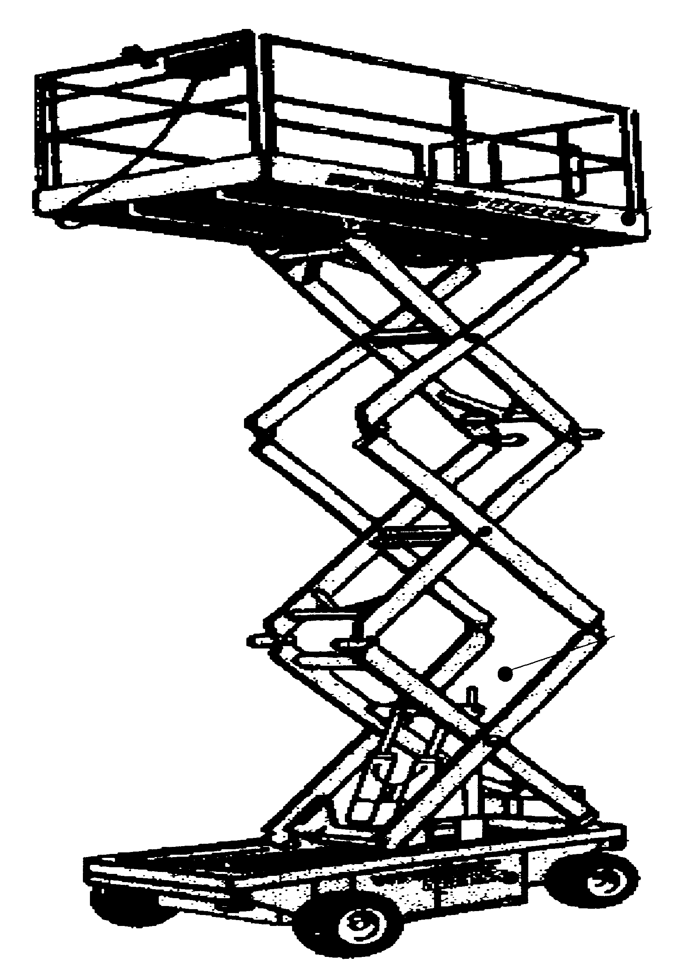 | Address:
Verify Check  Self closing gate | City/Suburb:
 | Phone:
Verify Check  Safety working load | Plant make:
 | Plant model:
 | Serial no.:
Verify Check  WARNING & RESTRICTION SIGNS | Signature:
 | Date:
 | Statement of operator competence required
Hydraulics  Verify Check  Rams  Hoses  Connections  (check for excessive  wear, leaks and creep)  Verify Check  Exhaust  (if applicable)  Verify Check  Safety prop  under scissor |  Plant to conform to manufacturer’s specifications and Plant Regulations.   Plant operator is to provide daily checksheets to WDA on a weekly basis   Where applicable, Personal Protective Equipment must be worn.   Plant Log Book detailing service history in accordance with Manufacturer’s specifications should be written legibly in English.   Contractor must produce proof of competence of operator, e.g., Certificate of Competence, Licence, detailed Log Book
Verify Check  Tyres  Wheels  Brakes  Park brake | WDA use only
 | Note: Sign only when all items have been checked
 | Plant check by:
Verify Check  Engine guarding  Instructions:  Verify Box to be ticked by Owner / Supplier / Operator prior to arrival onsite.  Check Box to be ticked after visual inspection by WDA | Position:
 | Date: |  | / /

